UI Design of tree density component:

0%:

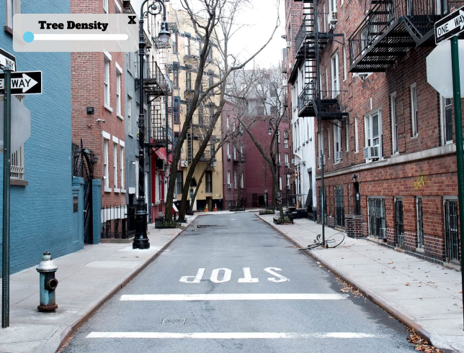

30%:

60%:

100%:

